Creating New project:
Creating and assigning projects in Practice.
This is for tracking current projects
Projects most commonly used for Admin Front Desk
1040FED- US Ind Income tax return ( Personal income tax returns)
1041FED- Income Tx Rtn- Est & Trsts (Returns for Estates and trusts)
1065 -Partnership Tax returns
1099- 1099 (1099’s to be created and mailed out)
1120FED- Corporate Tax returns (For business)
1120S – US Income Tx Rtn for S Corp (For Business)
1040X -Amended personal returns
1120X Amended Business returns
ENGMENTLTR – Engagement letter
FEDNOTICE- IRS Federal Notice
MISC-Misc Project
QUOTE-New Client Quote
REVIEW- Reviewed Financial Statements
SALESTAX- Sales Tax
TAXPRO- Tax Projections
TXPLN- Tax Planning
W2-W2 to be done

Practice Dashboard:
Select : Clients
Select: Dashboard
Search drop down: Client name/ ID number
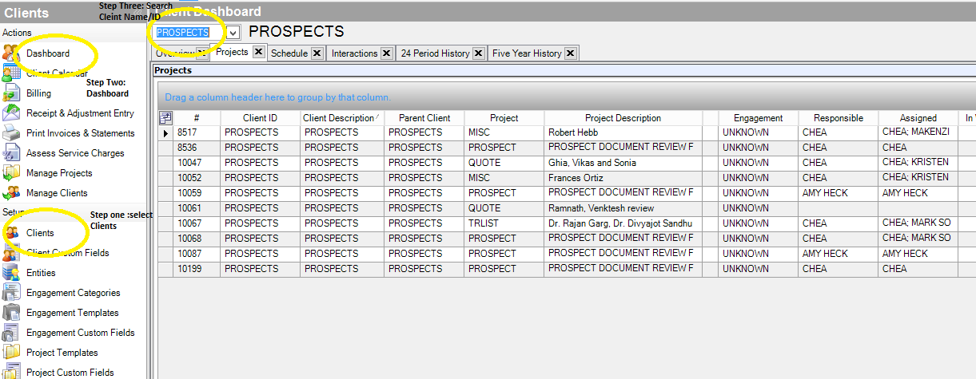

Right click and Select “Add Project”
Client : Search client ID
Project: Select project name ( use the list above for the most commonly used projects)
Description: This will auto populate with the project name,
Add referencing tax year
EX: US Ind Income Tax return 2022
Reviewed Financial Statements 09 2022
IRS Fed Notice Tx Yr 2021 payments

Received: Date project is created
Engagement: will auto file with “Default”
Select correct segmentation from “Platinum, Gold, Silver, Bronze, Inactive, Other”

Tracking: Select correct tracking description
EX: Ready for scanning
Ready for Processing
Ready to call client/ upload to portal
E-FILE FORMS OUTSTANDING
Ready for date entry
- For taxes select correct tracking from the “TR-“

Responsible: This will be the tax manager, (Amy, Chea, Cory, Mark, Joseline, Lila, Phil)
Staff: Will be the staff member that work will be assigned to process work (Scanning, Data entry, to contact client, to be extended)

Notes: Always note file with Date and brief description and initial notes
EX “5/5/22 Dropped off docs, sent to scanning -kms
5/6/22 Docs scanned to f/c, file “staff member” -kms
5/20/22 925-555-1234 LVM for “Client name” returns are ready for pick up -kms
5/21/22 Client name” in to p/u returns, signed e file forms, docs to Lorena-kms

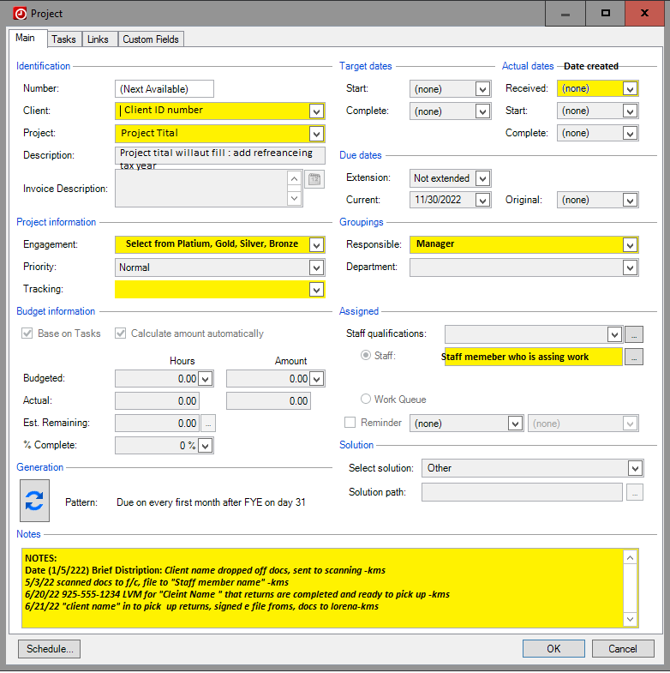

** Note project with any transaction that occurs with the client

Click “OK” to save project

